**ASSIGNMENT (MODULE-4) CSS AND CSS3**

**NAME:- NIKUNJ SAVALIA MOBILE NO.:-8866610103**

1. **What are the benefits of using CSS?**

* Cascading style sheets has several benefits for web developers and designers.
* Separation of content and presentation: CSS allows you to separate the content of web page (HTML) from its presentation (visual styling).
* This makes it easier to maintain and update the design of website, as changes to the CSS file can be applied to multiple pages on the site without having to edit each page individually.
* Consistency: By using CSS, we can ensure that the visual design of your website is consistent across all pages. We can define style for headings, links, buttons, and other elements once and apply them sitewide, ensuring that the design remains uniform and professional looking.
* Efficient workflow: With CSS, we can make changes to the design of a website quickly and efficiently, without having to edit each individual page.
* This can save a lot of time and effort, particularly for large websites.
* Accessibility: By separating content and presentation, we can create more accessible website that are easier for users to navigate and interact with.
* We can also use CSS to create responsive designs that adapt to different screen sizes and devices, making our site more user-friendly.
* Compatibility: CSS is supported by all modern web browsers, so we can be sure that our website will display correctly on a wide range of devices and platforms.
* In short, using CSS can help you create professional-looking, consistent, and user -friendly website that are easy to update and maintain.

1. **What are the disadvantages of CSS?**

* Cascading style sheets many disadvantages.
* With CSS, what works with one browser might not always work with another. The web developers need to test for compatibility, running the program across multiple browsers.
* There exists a scarcity of security.
* After making the changes we need to confirm the compatibility if they appear. The similar changes effect on all the browsers.
* The programming language world is complicated for non-developers and beginners. Different levels of CSS i.e. CSS, CSS 2,CSS 3 are often quite confusing.
* Browser compatibility some stylesheet are supported and some are not.
* CSS works differently on different browsers. IE and OPERA supports CSS as different logic.
* There might be cross-browser issues while using CSS.
* There are multiple levels which creates confusion for non-developers and beginners.

1. **What is the difference between CSS2 and CSS3?**

* CSS is capable of positioning text and objects.
* CSS3 is capable of making the web page more attractive and takes less time to crate. CSS3is backward compatible with CSS.
* Responsive designing is not supported in CSS.
* CSS3 is the latest version, hence it supports responsive design.
* CSS cannot be split into modules.
* Whereas CSS3 can be breakdown into modules.
* Using CSS, We cannot build 3D animation and transformation.
* But CSS3 We can perform all kinds of animation and transformation as it supports animation and 3D transformations.
* CSS is very slow as compared to CSS3.
* Whereas CSS3 is faster than CSS.
* In CSS we have set of standard colours and it uses basic color schemes only.
* Whereas CSS3 has good collection of HSL RGBA, HSLA, and gradient colours.
* In CSS we can only use single text blocks.
* But in CSS3 we can use multi-column text blocks.
* CSS does not support media queries.
* But CSS3 support media queries.
* CSS codes are not supported by all types of modern browsers.
* Being the latest version, CSS3 codes are supported by all modern browsers.
* In CSS, designers have to manually develop rounded gradients and corners.
* But CSS3 provides advanced codes for setting rounded gradients and corners
* There is no special effect like shadowing text, text animation etc. in CSS. The animation was coded in jQuery and JavaScript.
* CSS3 has many advance features like text shadows, visual effects, and a wide range of font styles and colours.
* In CSS, the user can add background colours to list items and lists, set images for the list items, etc.
* Whereas CSS3 list has a special display property defined in it. Even list items also have counter reset properties.
* CSS is memory intensive.
* CSS3 memory consumption is low as compared CSS.

1. **Name a few CSS style components**

* A few CSS style components include property, value and selector
* **Property:** A CSS property assign a style or behaviour to an HTML

element.

Ex.:- colour, border, margin, font-style and transform.

* **Value:** These are the specific values that can be applied to a property. For example ,the value “green” could be used with the “colour” property to change the next colour to blue.
* **Selector:** A CSS selector is the first part of a CSS rule. It is pattern of elements and other terms that tell the browser which HTML elements should be selected to have the CSS property values inside the rule applied to them. The element or elements which are selected by the selector are referred to as the subject of selector.

**Ex.:-**

<style>

        div{

            height: 100px;

            width: 250px;

            border: 2px solid black;

        }

        #one{

            font-weight: bold;

            color: green;

            font-size: 15px;

            margin: 10px;

        }

        #two{

            font-weight: bolder;

            color: blue;

            font-size: 10px;

            margin: 20px;

        }

    </style>

</head>

<body>

 <div>

    <p id="one">Nikunj</p>

    <p id="two">Savalia</p>

   </div>

</body>

</html>

**Selector:-** div, P , #one ,#two

**Property:-** height , width , border , font weight , color, font size

**Value:-** px , green , blue , bolder , bold , solid black

1. **What do you understand by CSS opacity?**

* The CSS opacity is used to specify the transparency of an element.
* Opacity will use between 0 and 1. In opacity 0 is completely (100%) transparent. 0.5 is image transference 50%. And 1 is no transparent.

Ex.:-

<style>

        div img{

            opacity: 0.7;

        }

    </style>

</head>

<body>

    <H1>NORMAL IMAG</H1>

    <img src="12.jpeg" alt="">

    <h1>OPACITY APPLY</h1>

    <div>

        <img src="12.jpeg" alt="">

    </div>

</body>

</html>

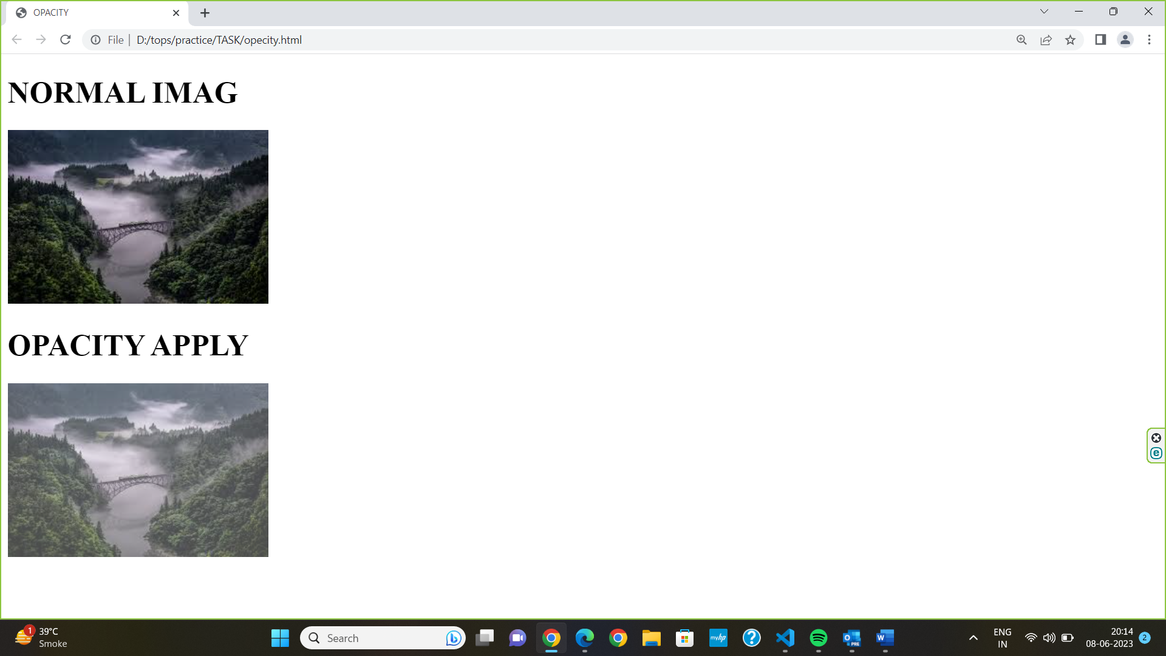

1. **How can the background color of an element be changed?**

* To change the background colour of an HTML element, we can use the background-colour CSS property and give it a value of colour.

Ex.:-

 <style>

        div {

            height: 500px;

            width: 500px;

            border: 2px solid black;

            background-color: cadetblue

            ;

        }

    </style>

</head>

<body>

    <div></div>

**Output.:-**

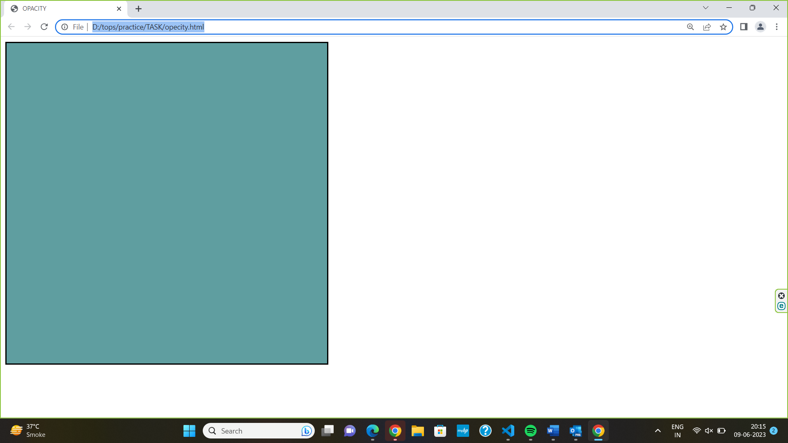

1. **How can image repetition of the backup be controlled?**

* To control image repetition of the backup in CSS, We can use the background-repeat property.
* This property is used to repeat the background image both horizontally and vertically.
* We can use the “no-repeat” value for the background-repeat property if you do not want to repeat an image, in this case , the image will display once.
* We can use background-repeat property in value added and image repetition of the backup be controlled.

**Ex.:-**

 <style>

    body{

        background-image: url(3.jpeg);

        /* background-repeat:no-repeat; */

        }

</style>

</head>

    <body></body>

**Output:-**

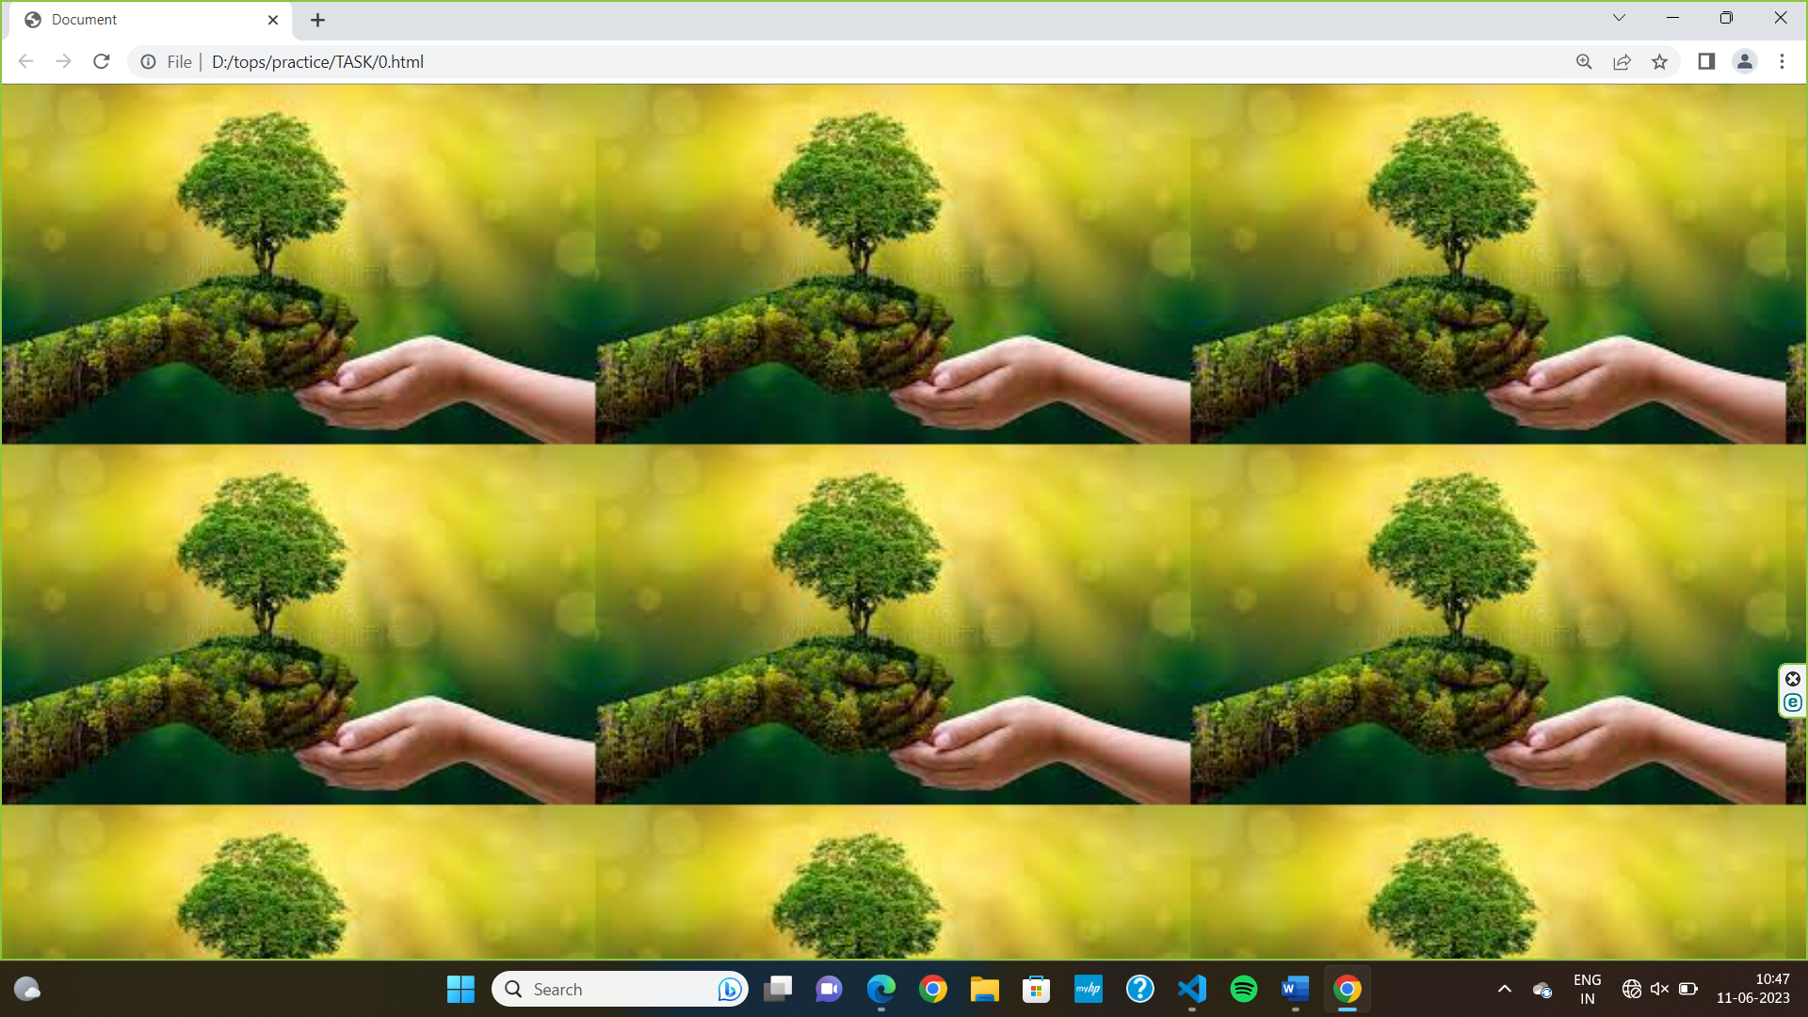

<style>

    body{

        background-image: url(3.jpeg);

        background-repeat:no-repeat;

        }

</style>

</head>

    <body></body>

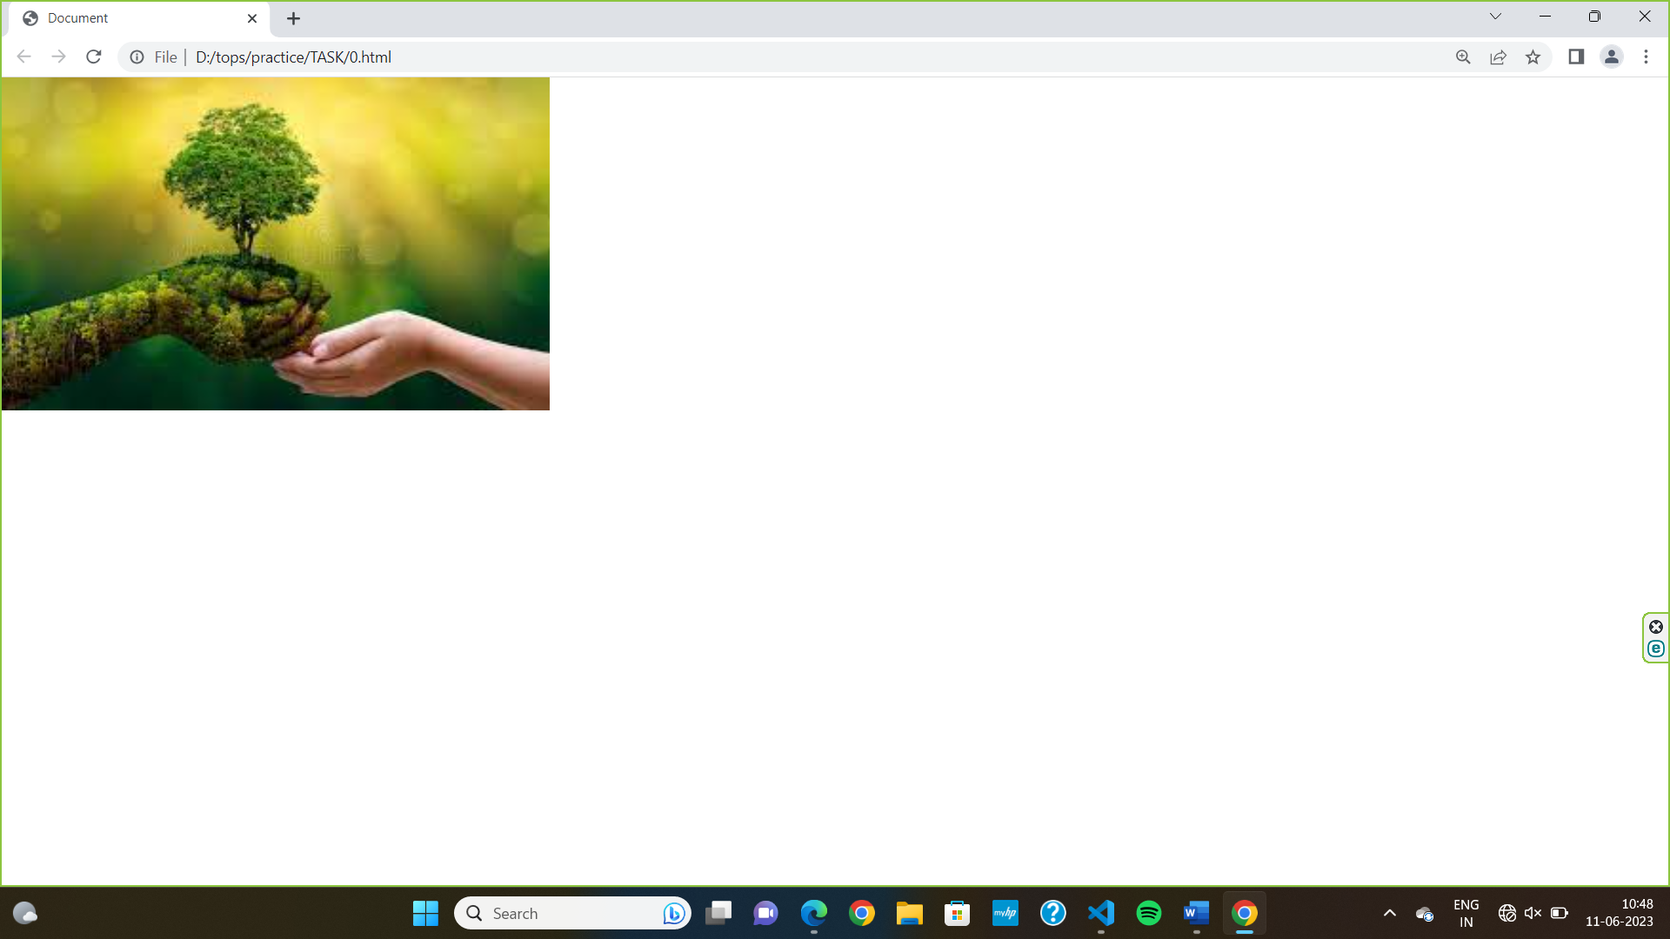

1. **What is the use of the background-position property?**

* The background-position property in CSS is used to set the starting position of a background image.
* By default, a background-image is placed at the top-left corner of an element, and repeated both vertically and horizontally.
* The position that is relative to the positioning layer can be set by using the background-origin property.
* For example, if we have an image that is 100px wide and 200px high and we want it to be positioned 10px from the left and 20px from the top of the element.

**Ex.:-**

 <style>

    body{

        background-image: url(3.jpeg);

        background-repeat:no-repeat;

        background-position: 10px 20px;

        }

</style>

</head>

    <body></body>

**Output:-**

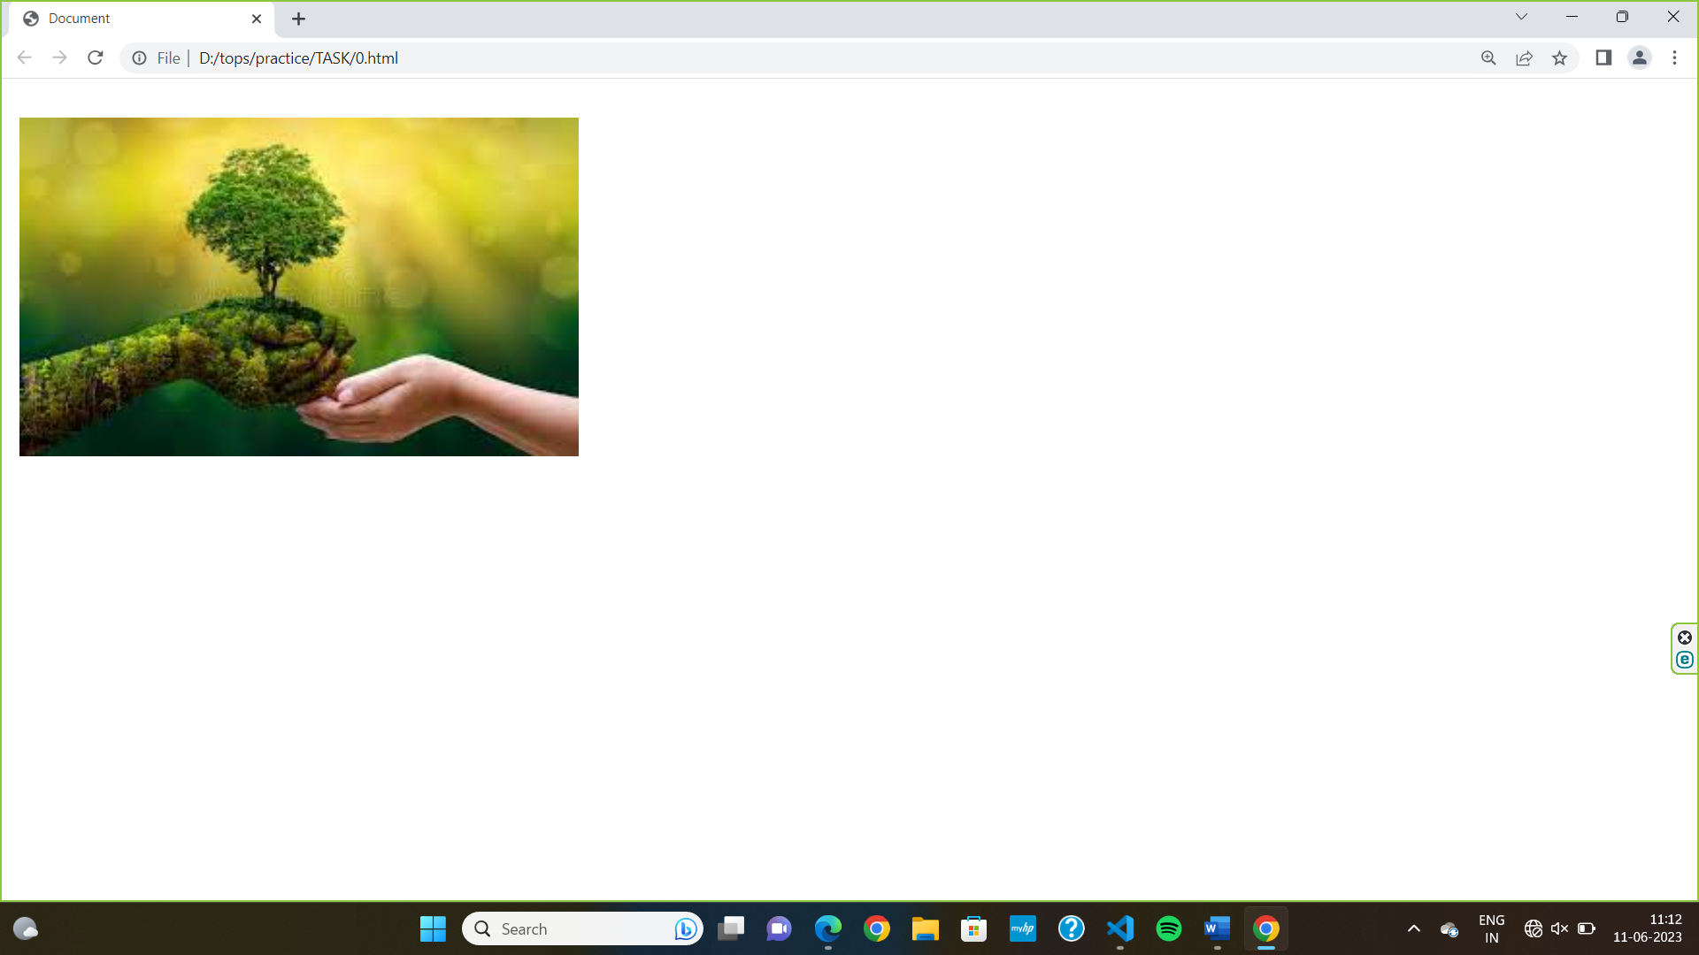

1. **Which property controls the image scroll in the background?**

* the background-attachment property in CSS is used to specify the kind of attachment of the background image with respect to its container.
* It can be set to scroll or make it remain fixed.
* Background-attachment : scroll , fixed , local, initial, inherit.

**Ex.:-**

 div{

        background-image: url(3.jpeg);

        background-repeat: no-repeat;

        background-position: center;

        background-attachment: fixed;

        }

</style>

</head>

    <body>

        <div>

<p>There were doors all round the hall, but they were all locked; and when Alice had been all the way down one side and up the other, trying every door, she walked sadly down the middle, wondering how she was ever to get out again.

Suddenly she came upon a little three-legged table, all made of solid glass;

there was nothing on it except a tiny golden key, and Alice's first thought

was that it might belong to one of the doors of the hall; but, alas! either

the locks were too large, or the key was too small, but at any rate it would

not open any of them.</p><br><br>

<p>There were doors all round the hall, but they were all locked; and when Alice had been all the way down one side and up the other, trying every door, she walked sadly down the middle, wondering how she was ever to get out again.

Suddenly she came upon a little three-legged table, all made of solid glass;

there was nothing on it except a tiny golden key, and Alice's first thought

was that it might belong to one of the doors of the hall; but, alas! either

the locks were too large, or the key was too small, but at any rate it would

not open any of them.</p><br><br>

<p>There were doors all round the hall, but they were all locked; and when Alice had been all the way down one side and up the other, trying every door, she walked sadly down the middle, wondering how she was ever to get out again.Suddenly she came upon a little three-legged table, all made of solid glass;there was nothing on it except a tiny golden key, and Alice's first thought was that it might belong to one of the doors of the hall; but, alas! Either the locks were too large, or the key was too small, but at any rate it would not open any of them.</p><br><br>

<p>There were doors all round the hall, but they were all locked; and when Alice had been all the way down one side and up the other, trying every door, she walked sadly down the middle, wondering how she was ever to get out again.

Suddenly she came upon a little three-legged table, all made of solid glass;

there was nothing on it except a tiny golden key, and Alice's first thought

was that it might belong to one of the doors of the hall; but, alas! eitherthe locks were too large, or the key was too small, but at any rate it would

not open any of them.</p>

        </div>

    </body>

**Output:-**

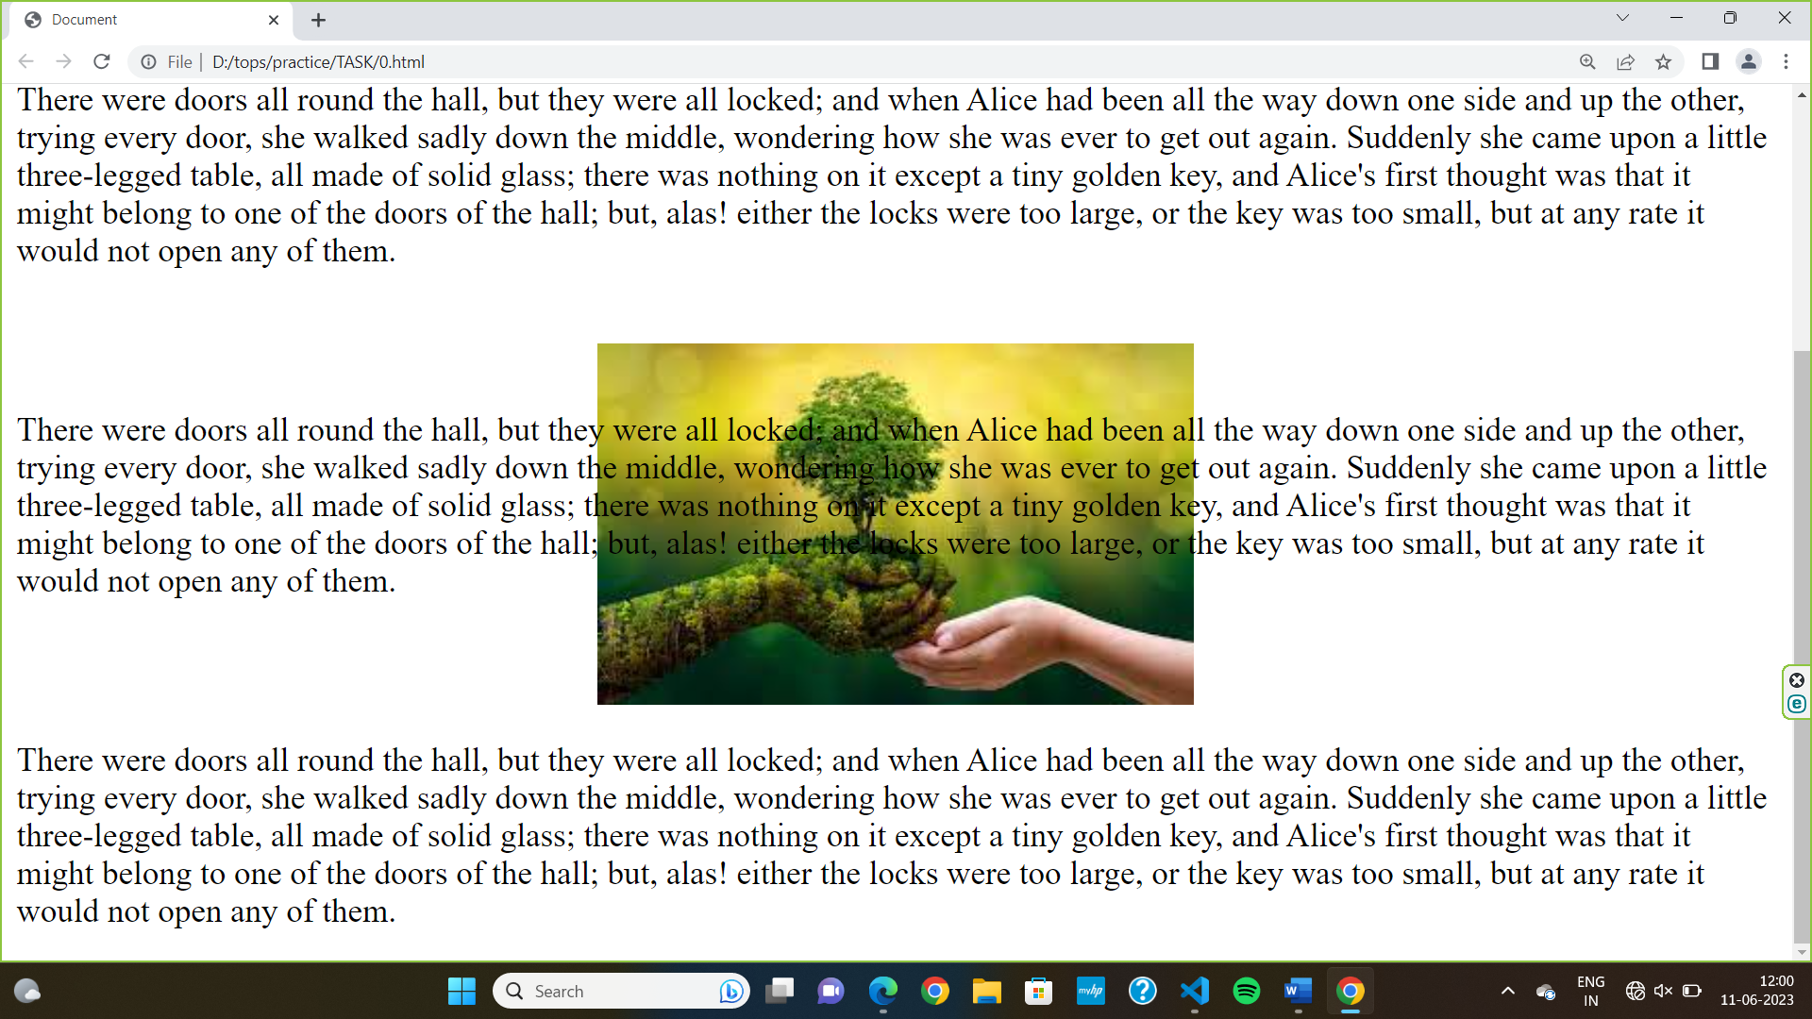

1. **Why should background and color be used as separate properties?**

* The background and colour should be used as separate properties because it makes the style sheets more legible.
* The background property is complex in itself and becomes all the more legible.
* The background property is complex in itself and becomes all the more complex with colour.
* Colour is an inbuilt property while the background is not one. And this can lead to a lot of confusion.

1. **How to center block elements using CSS1?**

* In order to centre the block-level elements, we need to set the margin-right and margin-left properties to explicit values.
* We can use the margin property by setting the values of margin-left to auto and margin-right to auto and width to some explicit value: block level element will centre itself.

**Ex.:-**

<style>

    div {

      width: 500px;

      border: 2px solid black;

      margin-left: auto;

      margin-right: auto;

      background-color: cornflowerblue;

      text-align: center;

    }

  </style>

</head>

<body>

  <div>NIKUNJ SAVALIA</div>

</body>

**Output:-**

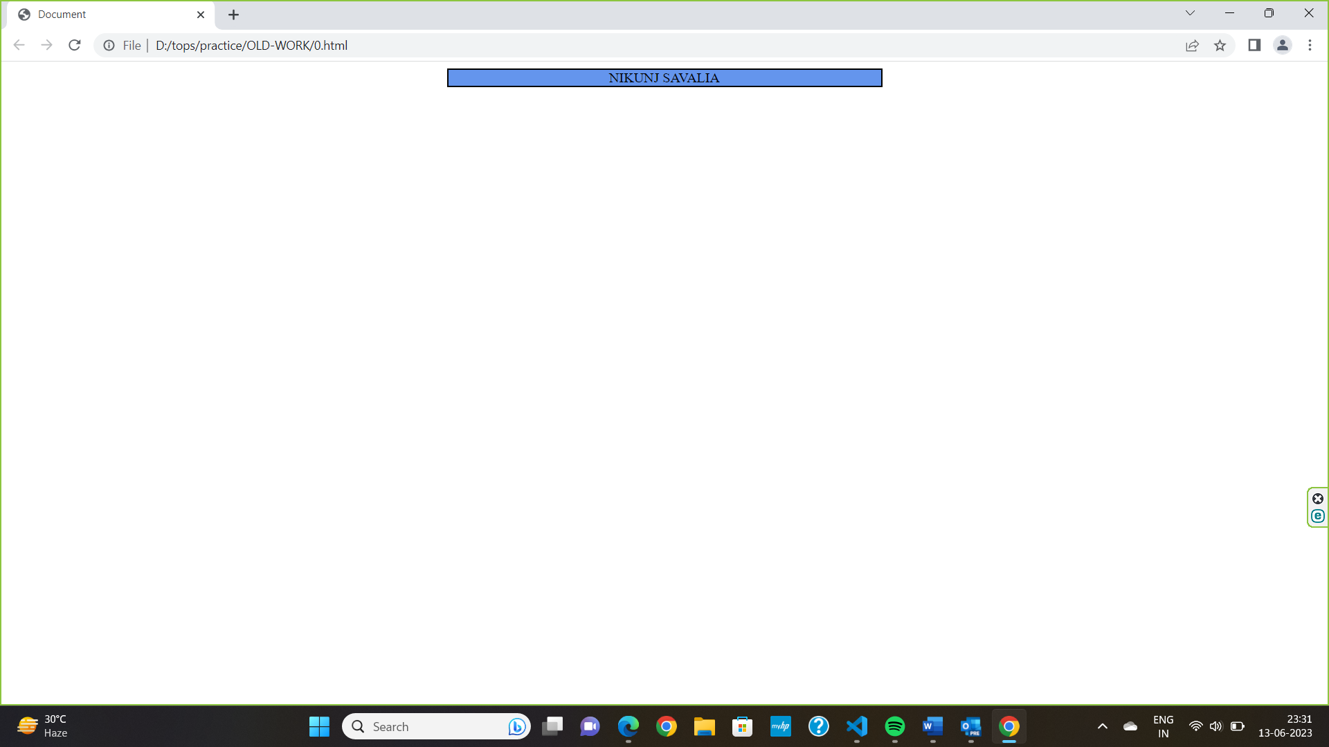

1. **How to maintain the CSS specifications?**

* Use valid CSS: Ensure that your code writing in the valid CSS format. Validate your CSS code using the tool like W3C validation service.
* Browser compatibility: Test your code with different browser and platform to ensure compatibility.
* Test and Debug: Regularly test the CSS code with different browsers and devices.

1. **What are the ways to integrate CSS as a web page?**

* **Embedded**: By placing the code in <style></style> element within the <head> element.

**Ex.:-**

<title>internal CSS</title>

  <style>

    div {

      color: teal;

      font-family: fantasy;

      font-size: xx-large;

    }

  </style>

</head>

<body>

  <div>NIKUNJ SAVALIA</div>

</body>

* **Inline :** HTML elements may have CSS applied to them via STYLE attribyte.

**Ex.:-**

<body>

  <div style="color: teal;font-family: fantasy;font-size: xx-large;">NIKUNJ SAVALIA</div>

</body>

* **Linked/imported:** place the CSS in an external file and link it via a link element.

**Ex.:-**

<link rel="style sheet" href="external.css">

</head>

<body>

  <div>NIKUNJ SAVALIA</div>

</body>

1. **What is embedded style sheets?**

* Embedded style sheet also known as internal CSS.
* With an embedded style sheet, you define the styles that apply to specific HTML elements or class within the same document.
* It defining CSS rules directly within the ‘<style>’ tags in the ‘<head>’ section of an HTML file.
* **Ex.:-**

<title>internal CSS</title>

  <style>

    div {

      color: teal;

      font-family: fantasy;

      font-size: xx-large;

    }

  </style>

</head>

<body>

  <div>NIKUNJ SAVALIA</div>

</body>

1. **What are the external style sheets?**

* In External css defining with make the another css file. And link with the <link> tag add in <head> tag portion of the html file.
* **Ex.:-**

<link rel="style sheet" href="external.css">

</head>

<body>

  <div>NIKUNJ SAVALIA</div>

</body>

1. **What are the advantages and disadvantages of using external style sheets?**

|  |  |  |
| --- | --- | --- |
|  | **Advantages** | **Disadvantages** |
| **1.** | External stylesheet promote a clear separation between the html and CSS of a web page. | using external stylesheet, the browser needs to make an additional HTTP request to retrieve the CSS file. |
| **2.** | External style sheets can be used across multiple html pages.by linking the same CSS file to different documents. | External style sheets can increase the initial page load time. |
| **3.** | Using external style sheets allow multiple developers to work on the HTML and CSS separately. | External style sheet require a separate CSS file to be present and accessible. if the file is missing and the link is incorrect, the style will not be applied correctly. |

1. **What is the meaning of the CSS selector?**

* CSS Selector can target element in various types like class, id, tags.
* **Class selector**: it targets all the class of elements and apply same style on all class given by you. Class selector is declared with “.”
* **Id selector**: it targets element based on their unique id attribute. it is declared with ‘#’.
* **Universal selector**: it targets all html code. And apply style in all html code. Universal selector will declared with ‘ * ’.
* **Group selector:** The grouping selector selects all the HTML elements with the same style definitions. It will be better to group the selectors, to minimize the code. To group selectors, separate each selector with a comma.

**EX:**-

 <style>

        /* universol selector */

        *{

*background-color*: black;

        }

        h1{

*background-color*: red;

        }

        /* group selector */

        h2,h3{

*background-color*: yellow;

        }

        /* class selector */

        .one{

*background-color*: green;

        }

        /* id selector */

        #two{

*color*: cadetblue;

        }

1. **What are the media types allowed by CSS?**

* Media types represent different output or media types.
* All: This is the default media type it is applies to all devices.
* Screen: This media type is used for computer screen, tablet and smart phones.

1. **What is the rule set?**

* The rule set is main building block of CSS style sheet.
* Rule set consists of a set of rules that determine how elements in a document should be displayed.
* The rule set is also known as Css-rule or style-rule.
* Rule set contains selector and declaration of one or more property and value.